Experiment-5: Configure Switch and Router

Aim:
To configure a switch and router with IP addresses so that PCs can communicate through them.

Apparatus/Software Required:
• Cisco Packet Tracer
• 1 Router, 1 Switch, 2 PCs
• Straight-through cables

Theory:
A router provides default gateway and connects networks. A switch connects devices in a LAN. For management, the switch can also have an IP address (on VLAN 1). Assigning IPs on router and switch allows us to test and manage them from PCs.

Procedure:

Step 1: Draw the Topology
Place a Router, Switch, and 2 PCs in Packet Tracer. Connect Router G0/0 to Switch, and connect Switch ports to PC1 and PC2 using straight-through cables.

Step 2: Configure the Router (CLI)
Open the Router → CLI tab and type the following commands:
Router> enable → Enter admin mode
Router# configure terminal → Start configuration mode
Router(config)# hostname R1 → Set router name as R1
R1(config)# interface gigabitEthernet 0/0 → Select port G0/0
R1(config-if)# ip address 192.168.1.1 255.255.255.0 → Assign IP address
R1(config-if)# no shutdown → Turn ON the port
R1(config-if)# exit → Exit interface mode
R1(config)# exit → Exit config mode

Step 3: Configure the Switch (CLI)
Open the Switch → CLI tab and type the following commands:
Switch> enable → Enter admin mode
Switch# configure terminal → Start configuration mode
Switch(config)# hostname S1 → Rename switch as S1
S1(config)# interface vlan 1 → Select VLAN1 (management interface)
S1(config-if)# ip address 192.168.1.10 255.255.255.0 → Assign IP to switch
S1(config-if)# no shutdown → Enable VLAN1 interface
S1(config-if)# exit → Exit interface mode
S1(config)# ip default-gateway 192.168.1.1 → Set default gateway as Router IP
S1(config)# exit → Exit config mode

Step 4: Configure PCs
PC1:
IP Address: 192.168.1.2
Subnet Mask: 255.255.255.0
Default Gateway: 192.168.1.1
PC2:
IP Address: 192.168.1.3
Subnet Mask: 255.255.255.0
Default Gateway: 192.168.1.1

Step 5: Test Connectivity
From PC1 → Command Prompt → ping 192.168.1.1 (Router)
From PC1 → ping 192.168.1.10 (Switch)
From PC1 → ping 192.168.1.3 (PC2)
All pings should succeed if configured correctly.

Network Topology Diagram:
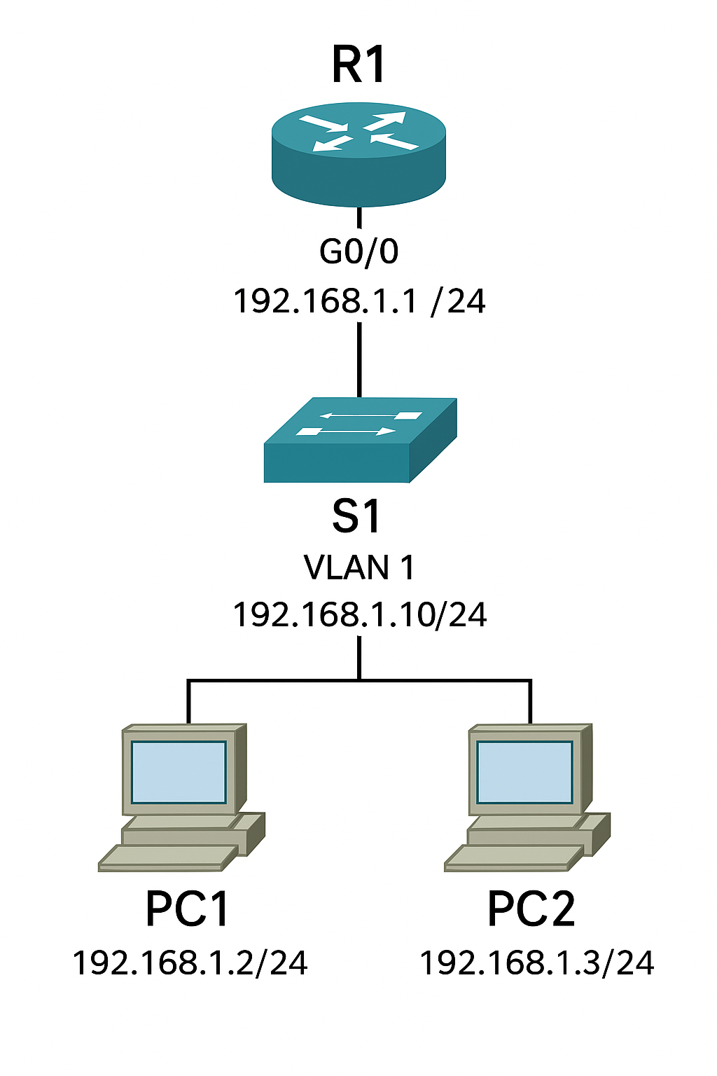

Result:
Router and Switch were configured successfully. PCs communicated with each other and with router/switch using the assigned IPs.

Viva Questions:
- 1. Why do we assign IP to VLAN1 on a switch?
- 2. What is the purpose of a default gateway on the switch?
- 3. Can a switch forward packets between different networks? Why not?
- 4. Difference between configuring a router interface and switch VLAN interface?

